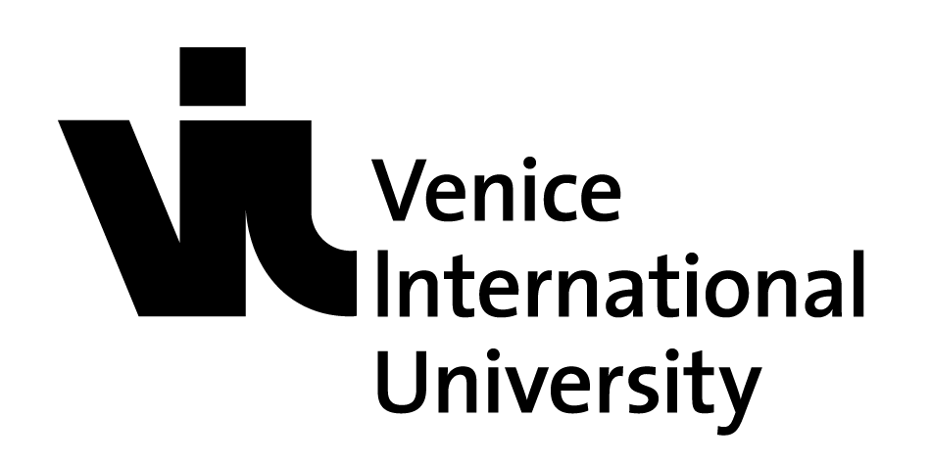

VIU PhD Academy
Global Challenges Series: WATER
Venice International University, 8-13 May 2017
This is the first in the Global Challenges Series of VIU International PhD Academies. Each intensive PhD Academy will focus on a major societal challenges faced by humankind today, which will be addressed via multidisciplinary approaches, involving high-level speakers selected among the VIU member institutions but whose remarks will be adapted to a broad cohort of the VIU community. This opportunity is open to PhD candidates from the member universities of VIU.
This edition, leaded by Bordeaux University and INRS, Canada relates to the issue of water, addressing different aspects: ecological, eco-toxicological, economical, sociological, cultural, political, juridical, public health, etc. They will be discussed in abundantly illustrated lectures involving real dialogue among participants, round-tables and concrete indoor/on-site examples:
Candidates from VIU member universities will pay no participation fees.
Grant support is available to support, fully or partially, travel and accommodation costs
Deadline for Application: February 28
For further information
E. Phdacademy @univiu.org
http://www.univiu.org/research-training/phd-academy

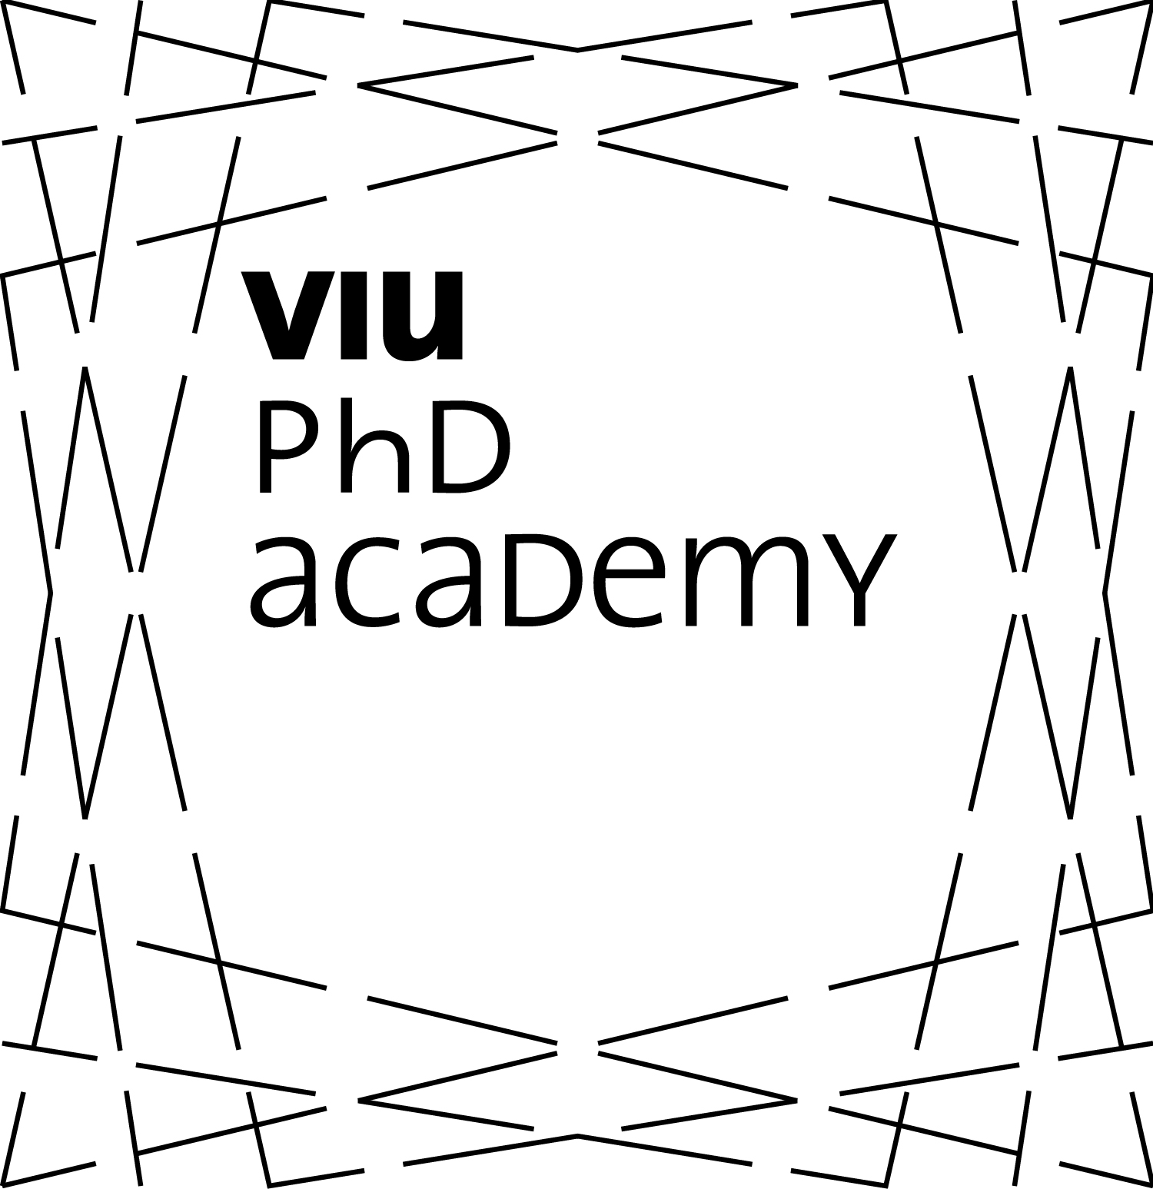

VIU Summer School
Responsible Capitalism: Micro and macroinstitutional conditions of transformation
Venice International University, May 29- June 1, 2017
In its second edition, the Summer School on Responsible Capitalism is an initiative of VIU in cooperation with the two member universities Ca’ Foscari University of Venice and University of Lausanne.
It aims at the development of ideas that promote a more sustainable future by bringing together young scholars from all over the world to discuss their ideas on the future of Capitalism from the microlevel of individual decision-making to the organizational and the societal level. Participants will be made familiar with recent research from a broad set of disciplines. They will work on their ability to engage in the transdisciplinary discourse which is required for the development of innovative answers to grand sustainability challenge.
Applications are welcome from current PhD students, post-doc researchers in Management, Strategy, Organization Theory, Finance, Economic Sociology, and related disciplines from universities worldwide.
Deadline for Application: February 28
For further information:
E. summerschools@univiu.org
http://www.univiu.org/shss/seminars-summer-schools/responsible-capitalism

VIU Summer School
Summer Institute on Ageing
Venice International University, June 5 – 9, 2017
The 5th edition of the Summer Institute on Ageing continues the settled collaboration between Venice International University and its members Ca' Foscari University of Venice, University of Padua, Universitè de Lausanne and the National Research Council.
The program is intended to offer to students a set of activities to deepen the understanding of the ageing process ranging from some basic notions of the medical and epidemiological literature, to an extensive treatment of economics (pensions and retirement, ageing in society and intergenerational relationships) and social sciences (role of family networks).
Learning outcomes are of two types: on one hand participants will gain more insight into the recent advances of the ageing process from a theoretical and practical point of views and will also be able to evaluate the impact of these advances (e.g. health care costs); on the other participants will take part into a “hands on” session that will teach them how to use the data behind the research effort in this area.
The Summer Institute is addressed to mainly graduate and PhD students in economics, medicine, political science, psychology and sociology. High level policy makers and high level officials in public and private institutions will be admitted if their background is adequate.
Deadline for Application: 31 March 2017
For further information:
E. summerschools@univiu.org
http://www.univiu.org/shss/seminars-summer-schools/ageing-institute

VIU Summer School
Critical Infrastructure Resilience
Venice International University, June 26 – 30, 2017
At its first edition, the summer school on Critical Infrastructure Resilience brings together academics and professional experts to discuss an emerging topic with a pragmatic and scientific approach.
The School is led by University of Tor Vergata, in cooperation with Waseda and Lund Universities.
The city of Venice will be used as a laboratory and students will learn first hand how to identify a critical infrastructure, assess its risk, develop resilience strategies and devise ways to apply them. The course consists of a mix of theoretical knowledge, case studies/projects and hands-on exercises and will provide participants tools to analyze a system and its components, prioritize connectivity, assess risk, and develop resilience strategies. These techniques can be applied to various fields and at various scales, from city scale to a global supply chain.
The course. Graduate students and working professionals from any university, research institute, or other organization (private companies, government agencies, NGOs) with an interest in critical infrastructure issues and ability to read and write fluently in English. Advanced undergraduates will also be considered.
Deadline for Application: March 10
For further information:
E. summerschools@univiu.org
http://www.univiu.org/shss/seminars-summer-schools/critical-infrastructure-resilience

VIU Summer School
Macroeconomics, Growth, and the Environment (EAERE-FEEM-VIU)
Venice International University, July 2 – 8, 2017
The summer school is promoted in cooperation with the European Association of Environmental and Resource Economists (EAERE) and Fondazione Eni Enrico Mattei (FEEM).
Some of the most pressing environmental and resource problems – including climate change, deforestation, urban air pollution – are closely related to economic growth. Environmental policies have macroeconomic impacts. The aim of the 2017 Summer School is to provide tools and methods to study the intersection between macroeconomics, economic growth, and the environment.
The lectures will first present theories of how environmental problems are coupled to – and can be decoupled from – population growth and technical change in the long run and will present work on how environmental policies affect the macroeconomy, growth and the direction of technological change.

The program is aimed at Ph.D. students who are writing a thesis on the dynamic macro-economics of environmental and resource problems or climate change and want to engage into a highly interactive exchange with experts in the field. Successful candidates from VIU's member universities will benefit from additional support from VIU, consisting of partial or full coverage of the participation fee and the EAERE association fee.
Deadline for Application: February 15

For further information:
E. summerschools@univiu.org
http://www.univiu.org/shss/seminars-summer-schools/eaere-feem

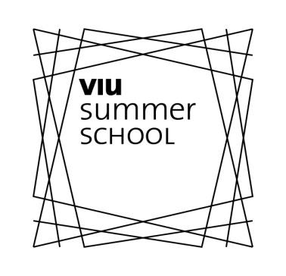

VIU Graduate Seminar
Understanding and Managing Climate Change: Coping with Sea Level Rise
Venice International University, July 10-22, 2017
The Graduate Seminar, coordinated by Duke University and the participation of Ca’ Foscari, Padua, INRS, KuLeuven, Iauv Universities and CNR will give students a broad perspective on the impact of Climate Change and Sea Level Rise upon coastal areas from the social, economic and environmental points of view.
Causes and consequences of global warming, and its impact on the state of the oceans and internal seas will be addressed and discussed, and changes in the hydrological cycle will be examined. Using data and models to explore future scenarios, the impact of sea level rise on coastal morphology, ecosystems, water resources, population and health will be presented and discussed. Students will explore, in class and in the lab, state-of-the-art monitoring technologies and available datasets. Through analysis of adaptation and mitigation strategies and engaging discussions on critical management issues, students will develop their own critiquing concepts in a multidisciplinary framework. The Venice Lagoon will be used as a “laboratory”, the ideal case-study to explore the intertwined dynamics of human and natural system.
Master's students and PhD candidates from the VIU member universities will pay no participation fees. Grant support is also available to support, partially or fully, their costs of international travel and accommodation.
Deadline for Application: February 28
For further information:
E. summerschools@univiu.org
http://www.univiu.org/shss/seminars-summer-schools/rising-sea-levels

